Prehistoric tomb surveying (5)
Small hunebedden or pseudo-dolmens

Dirk Kruithof, September 2019

While studying the geometry of Neolithic tombs along the Baltic coasts and in the Netherlands, the similarities between the early forms of the Baltic dolmens and the later smallest Dutch hunebedden became more and more conspicuous. Not only their tomb plans followed the rules of the grid-of-squares geometry (see for example PTS-4 ), but some tombs did have identical setups. The idea came off that those small hunebedden should be regarded as a hybrid form - dolmens that were turned into a hunebed by adding an end stone in the place where real dolmens have their entrance. In this paper the geometrical characteristics that make them comparable are highlighted.

Hunebed D22, a mix of dolmen and hunebed

If one expects to find regularities one also has to expect exceptions. This is what Van Giffen experienced when he excavated hunebed D22 in 1918. The hunebed lies hidden in a small mound - only two supports are visible. For his atlas of hunebedden, Van Giffen located the hidden ones by means of a dipstick. Thus, he found side stone Z1' . Later on, when he excavated the hunebed, side stone Z1' appeared to exist of two small supports instead of the expected single stone. The expensive plates for the atlas had been created already and except for a textual rectification Van Giffen did not pay more attention to it. Generally, such peculiarities are imputed to the availability of stones or the caprices of the tomb builders but probably this one should not. During the preparations of the study of geometrical features of dolmens along the Baltic coasts, a rather similar ground plan to that of D22 was found in the work of Schuldt. His plan of the erweiterde Dolmen 385b of Serrahn can be used as an overlay over hunebed D22, so that two striking features come to light (figure 1). Firstly, in the position of the double stone Z1' dolmen 385b has a small stone fence so that the two half supports of D22 seem to be there on purpose. Secondly, dolmen 385b has both an end stone

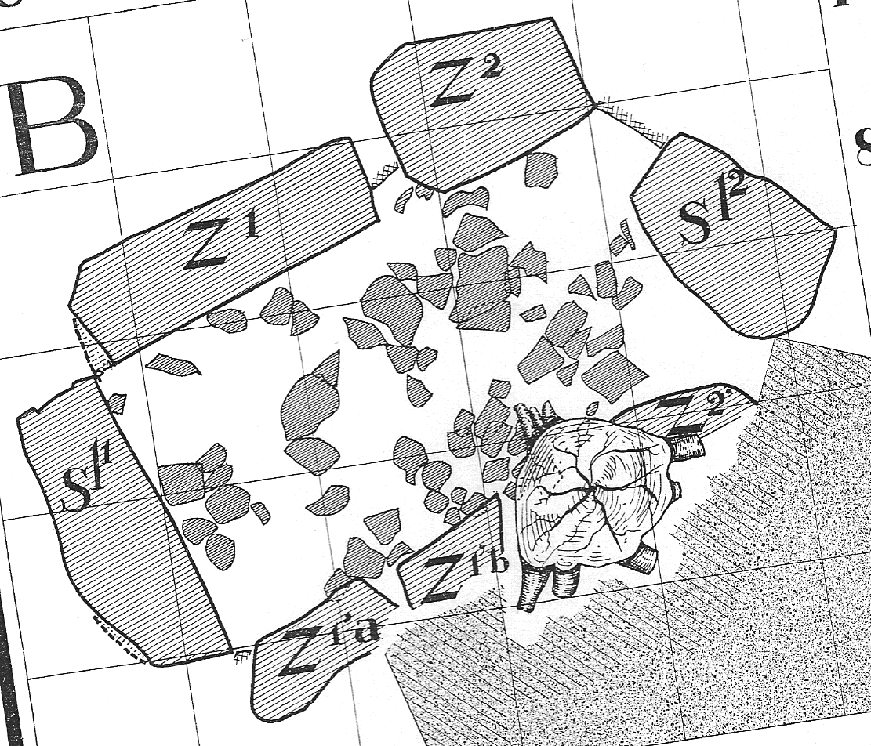
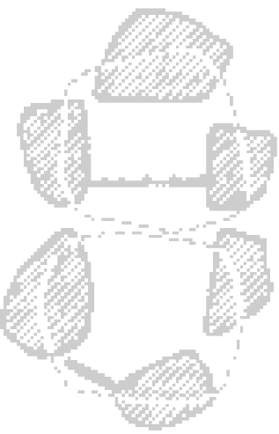
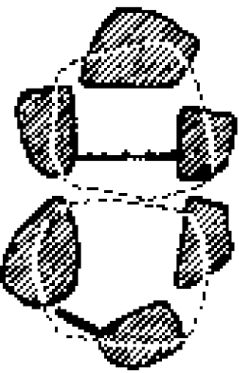
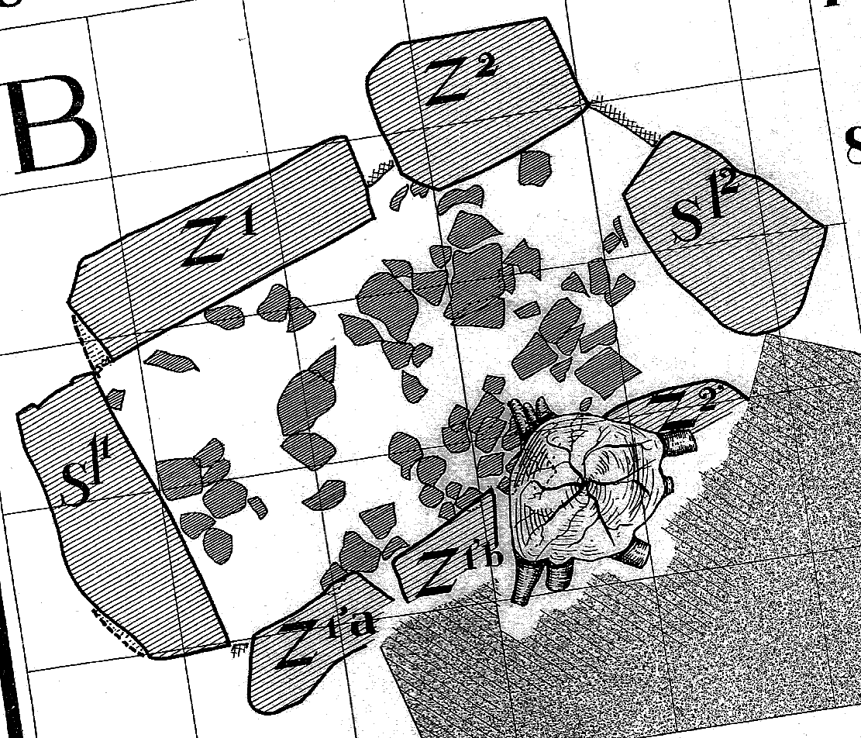

Figure 1
Comparison of hunebed D22 (left, Bronneger, the Netherlands) with Erweiterde Dolmen 384 (right, Serrahn, Germany).
D22 according to Van Giffen (1925/27), Atlas, plate 145. Dolmen 385b according to Schuldt (1972), pg.165, table 11b.
Figure 2
Numbering of tomb stones.
Z1
Z2
Z3
Z1'
Z2'
Z3'
S1
S2
P1
P1'
D1
3
D2
T1
T2
T3
T3
117º
117º
117º
prismatic hole
117º
117º
a b c d e

Figure 3
These dolmens have the same proportions, but do not have the same dimensions or orientations.
(a) G5, Raemaekers and Jansen 2013, p.7 (d) 384, Schuldt 1972, p.76
(b) D22, Van Giffen 1925/27, Atlas, plate 145 (e) 409, own field plan
(c) 385b, Schuldt 1972, p.165

and a door slab (Türplatte) in the position where other erweiterde Dolmens have a clear entrance. As if it is half dolmen and half passage grave . Most peculiar, in the overlay the inner side of this end stone touches the outer side of the corresponding end stone of D22. Furthermore, the area encompassed by these touching faces and the double stone (D22) / fence (385b) has the same shape as the ground plan of some real dolmens. There a door slab standing with a characteristic 117º angle to the chamber orientation produces an encompassed area that unlikely arises by happenchance (figure 3). This same form is encompassed in D22 and 385b. All in all, these are too much oddities to be neglected and the question rises if there exist other hybrid hunebedden.

Hunebedden D22 and D13, different ground plans but identical setups

In PTS-4 it is argued that the grid of squares for the setup of hunebed D22 is a derivative of the nearby hunebed D21, which seems to be older because of the findings. The grid is orientated at 43º, which is a common feature amongst Neolithic tombs and can be generated in two steps using the grid-of-squares geometry. A nice example comes from hunebed D13, where the setup can be followed in the ground plan actually (figure 4). It starts off with a grid that is orientated at the cardinal points. In the grid a diagonal through a field of 2×3 squares is 'drawn' . Side stones Z1 and Z2 were placed along it. Upon this diagonal the bisection of a diagonal through two adjacent squares is used to get the final orientation of 43º. This grid is used to produce an inscribed Pythagorean triangle of sides 3×4×5. Both the bisection of and the inscribed right triangle are common features of Neolithic tomb plans. The surveyor of D13 must have planned the layout in advance and put the stones into place according to the plan. The right angle of the triangle fits to the interstice between side stone Z1 and Z2, while these stones stand along the initial diagonal. Triangle tops fitting to interstices is another often seen feature, so that we may assume it was designed deliberately.
2×3
1×2
43º
43º
Figure 4
The three consecutive stages of the orientation of hunebed D13. Most right: comparison to the plan of D22.
The dotted line comes from hunebed D21, from where the orientation was taken. See PTS-4, figure 30.

At first glance the ground plans of D13 and D22 are rather different. D22 has a rectangular chamber while the chamber of D13 widens to the northeast and has a kink between side stones Z2 and Z3 in the northern wall. Only the orientation of the southern wall seems to be a commonality. A closer look reveals a similar tomb diagonal at 43º, which forms the jumping-off place for the setup of both tomb plans. Within the grid the inscribed Pythagorean triangle is formed, although its position in D22 conforms to dolmen 385b more than to D13. Additionally, one finds parallel sightlines at 167º and 193º. Parallel sightlines are known as a characteristic phenomenon of orientation from the threesome hunebedden on a field near D22 (Bronneger) and from a comparable group near Emmen (see PTS-4). Because of the sightlines it becomes clear that the surveyors of D13 and D22 had a similar setup in mind but implemented it by a different stone configuration. Since the applied grid at 43º depends on the bisection of upon a diagonal through a field of 2×3 squares, the sightline at 167º could be created via reverse engineering easily. Azimuth values of 167º and 193º are the most applied orientations amongst Neolithic tombs. Their mutual angle is constructed by while true south forms its bisection (figure 5, lowest inset).
Figure 5
The construction of sightlines at 167º and 193º in the hunebedden D22 and D13. The grid of D22 (top) is based on foot size of 26½ cm (see PTS-4, figure 30).
167º
193º
167º
3
2
2
1
193º

Hunebed D22 compared to D12 and G5

Currently the remains of hunebed D12 exists of one end stone and three side stones in a row. When Van Giffen restored the hunebed in 1952, he also performed a cursorily excavation in order to judge upon the dimensions of the chamber. On several places in the extension of the remains he found pits filled with sand, which he called extraction pits. Van Giffen assumed that the hunebed consisted of five trilithons initially. Later Raemaekers and Jansen pointed at the fact that Van Giffen did not find any pieces of chamber filling in the
extension and that there were no remains of a chamber floor. According to them the hunebed never did have more than three trilithons. Since D12 has much in common with the true dolmen G5 - similar dimensions, number of supports and orientation - they suggested that D12 could have been a true dolmen too.

Dolmen G5 lay hidden under a 2-meter-thick clayey soil until it was dug up during the development of an industrial park near Delfzijl (the Netherlands) in 1982. Its discovery surprised the archaeologists in two ways. G5 had its entrance at the short side and was labelled as the only Dutch dolmen therefore, and secondly it had been dismantled in prehistoric times already. Its capstones lied scattered around. Although nothing can be said about the motive behind the configuration, it proves that prehistoric people altered a tomb after its initial usage already.

Tomb D12 and G5 have a longitudinal azimuth of about 143º. The comparable orientation should not be ascribed to the possibility that they are of the same tomb type but to the identical geometrical setup for the ground plan. The azimuth can be interpreted as an offset by a Pythagorean triangle on due east (90º + 53º). In fact, the idea of the ground plan of D12 is more similar to that of D22 in the way that both tombs have the outside of an end stone along the grid of squares that produces the inscribed triangle. If D12 should be compared to D22, then it likely had a second end stone too (S1 in figure 6). At the northwestern end, where this end stone should be expected, the mound and soil had been disturbed heavily, which leaves us with the impression of stone digging.
1:2
1:2
Z3'
Z2'
S1
Z1'
Figure 6
Dolmen G5 (top) and hunebed D12 (bottom) get their comparable orientation from the same geometrical setup.

Although the setup of D12, D13 and D22 is comparable to that of true dolmen G5, there is a big difference. Where G5 has the entrance at the short southern side, D12, D13 and D22 have a blocking end stone in that position. The entrance of D13 and D22 is found between the uprights Z2' and Z3' as it is in the other small hunebedden and this can have been the case in D12 too. Unfortunately, the entrance position of D12 remains indecisive, since the side stones of the southwestern wall have been robbed and no excavation has taken place. Furthermore, considering the disintegrated condition of dolmen G5, this dolmen could have been destined for a reconfiguration. Only the placement of an additional end stone would have sufficed to adjust it to the habit of the small Dutch hunebedden. But this can be no more than an unsubstantiated guess since the prehistoric renovation or dismantlement of G5 was never completed.

Yet another five comparable hunebedden

Setups with an inscribed triangle orientated to the cardinal points seem to have been popular for the small Dutch hunebedden. Apart from G5 and D12 we find them again in the hunebedden D25 and D40. In PTS-4 these hunebedden are presented as a central hunebed having two satellite hunebedden each. Furthermore, the ground plan of D25 was virtually
restored concerning the subsided second and third trilithons. Thereby it occurred that D25 exists of two halves as if it is a combination of two dolmens facing each other. Each half consists of two trilithons and thereby has the same configuration as D40. The eastern 'dolmen' of D25 has the dimensions of an erweiterde Dolmen while the dimensions of the western part is comparable to a Groβdolmen . Chronically the erweiterde Dolmen precedes the Groβdolmen.
Figure 7
The geometrical setup of tomb D25.
(Virtually restored - see PTS-4)

In the discussion of how the tomb type Ganggrab (passage grave) could have evolved from the Groβdolmen, it is put forward that some dolmens got elongated per trilithon initially. Hunebed D25 sheds another light on the subject. Where three-trilithon-hunebedden display a 'single dolmen' geometrical setup for the complete hunebed, D25 being a four-trilithon-hunebed is divided into two partitions by means of a 'double dolmen' setup. Because of the different dimensions for both parts, the hunebed can have been built in two phases actually . Both 'dolmens' do not fit to each other exactly either. The southern wall of the eastern part stands a little to the outside of the western part although it is the smallest of the two. The configuration of a double dolmen does not exclude other developments that can have led to the passage grave type. Probably Neolithic surveyors did not apply a standard method of elongation but were pioneering. Yet, while the form may have been subject to the experiment, in D25 the surveying method using the grid-of-squares geometry remained the continuous factor.
Figure 9
Top: Ground plan of D38. Stone Z4’ can have been turned ±90º to its current position.
Bottom: A possible initial stage as an erweiterde Dolmen.
Figure 8
The geometrical setup of tomb D39.

D38 is another hunebed that can have started as a dolmen. In PTS-4 the strange position of D38-Z4 is discussed – at the moment being an entrance stone but maybe initially a side stone. In that case the northeastern part of the hunebed looks like an ordinary erweiterde Dolmen. It follows a straightforward application of for its orientation, and the dimensions of the chamber are defined by an inscribed Pythagorean triangle with sides 3×4×5. The hunebed has not been excavated.

The list of dolmen-like hunebedden is completed by another two small hunebedden, D6 and D39. Thereby all small hunebedden seem to have been subject to a geometrical setup comparable to that of true dolmens. Both D6 and D39 have the entrance in the same position as the other small hunebedden. The tomb plan of D39 near Emmen is ambiguous regarding the pure geometrical setup (see PTS-4).
Figure 10
The geometrical setup of tomb D39.
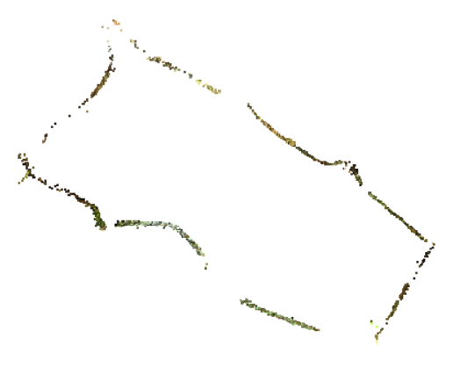
Compared to the other tombs in the list, the most straightforward setup is preferable having the top of the inscribed triangle fitting to the entrance. D39 makes part of a group of three hunebedden of which the geometrical properties are interrelated (see PTS-4).
3:4
43º
Figure 11
Horizontal cross-section of a 3D model of the chamber of D6, showing the geometrical setup.

D6 near Tynaarlo makes an exception amongst the Dutch hunebedden in that it has not been touched in modern times
– neither by excavation nor by vandalism. Additionally, the original configuration has been conserved very well. The northern wall forms the basis of an inscribed right triangle having sides 3×4×5. Its top is found between the side stones
43º
Figure 12
The geometrical setup the Urdolmen of Barkvieren.
– a situation found in the Urdolmen of Barkvieren too .

Although the Urdolmen is much smaller, yet both tombs show the same ratio between height and width because of this position of the triangle top. They utilise azimuth 43º as their base orientation, although in D6 the grid-of-squares is orientated via an offset by means of a 3×4×5 triangle.

Pseudo-dolmens in the Netherlands

The small tombs of two or three trilithons seem to take up their own position in the spectrum of the Dutch hunebedden . Both their geometrical setup and their dimensions can be linked to the properties of true dolmens. Based on the dolmen like geometrical setup, such small hunebedden could be called pseudo-dolmens, therefore. Such a pseudo-dolmen can be typified as a hunebed of two or three trilithons of which the geometrical setup produces an inscribed right triangle constructed in an orientated grid of squares. The pseudo-dolmen cannot be called a true dolmen since it does not have its entrance in its short side. Yet there is a 'hard' linkage to the dolmens in the area of the Baltic coasts in the form of hunebed D22 and dolmen 385b. Moreover, the idea of mutual influences is supported by the ceramic finds of some hunebedden. Kuyavish elements are present in the finds of Brindley's horizon 4 and 5 . Yet they are of later date than the earliest finds of pseudo-dolmen D22, which come from horizon 3 (a difference of about 50 years). Apparently, the influencing of geometrical setups predated that of cultural elements. This agrees with the view of Kim, who states that the spread of techniques follows the path of decision makers amongst the elite, while other cultural utterances spread by means of contact between ordinary group members (PTS-1) . Probably the surveying techniques came by a different carrier as the adoption of the Kuyavish
ceramic style. The people who created the dolmen like setups in the Dutch regions, can have maintained interregional contacts sharing their technical state of the art. Only a few decennia later, broader contacts followed in the wake of them, exchanging other cultural elements.

Reverences to the other papers of this study are abbreviated 'PTS-n', where PTS stands for the study title 'Prehistoric tomb surveying' and 'n' for the serial number of the paper.
The numbering of the stones follows the system of Van Giffen (figure 2). Additionally, the trilithons (consisting of two side stones and a capstone) have been numbered too.
Numbering according to Sprockhoff. Dolmen 385b no longer exists.
In the strict classification of Schuldt dolmen 384 should be regarded as an intermediary between the early pure form of an erweiterde Dolmen and a derivative form having the entrance between the short and long side of the dolmen. Schuldt (1971, pg .23)
Most likely this was reached by stretching a rope between poles (see PTS-2).
For a discussion about the possibility that Neolithic surveyors could have performed a bisection see PTS-1, pg.10 ad(4).
Because of the ease of reading and understanding, in this paper the wording '(a) diagonal(s) through two adjacent squares' will be replaced by the icon , which shows exactly what is meant by it.
Raemaekers and Jansen 2013, pg.4,5
Schuldt 1972, pg.22/24
This is extensively discussed in PTS-4.
This interesting dolmen is discussed widely in PTS-7. Although one of the earliest dolmens, it has a clever setup, which must have been produced by a skilful surveyor.
Maybe the larger hunebedden lost their dolmen like structure or the dimensions were not suitable for a setup that incorporated the right triangle. Any way it is hard to find benchmarks that connect the majority of their chambers to the grid of squares geometry. Nevertheless, it seems that their entrances can be linked, which is the subject of PTS-6.
Bakker 1973, pg.244/246. The Kuyavish elements appear in Havelte E, which corresponds to Brindley's horizons 4 and 5. The earliest ceramics from D22 comes from horizon 3.
Kim 2003, pg.285

